Estd: 2051

Haldibari R.M.-3,Jhapa

Subject: Computer Science Submitted to: HSEB Board, Submitted BY: Dhan Bdr Karki Sanothimi, Bhakatapur,

Sagar Ankhewa Nepal

Prajwal Puri Date: Grade: XI External:

Guided by: Mr. Raju Shresta

Date: 2075/11/22

Internal:

**PREFACE**

It gives me an immense pleasure in presenting this project of grade XI as this is my first project that I’ve ever did. This project is done specially to summit the final project work according to the contents of grade XI. In the project, I have attempted to present the subject matter related to various content of computer using HTML and CSS. I have used notepad, Notepad++, Google, and other various applications for writing the code and finding their output while preparing this project. Furthermore, I have included the work based on html about famous districts or places of Nepal in a convenient way.

**DECLARATION**

I hereby declare that the project work entitled *“*COMPUTER” is a HTML project, original work done by me, and this project work is submitted in the requirements for the award degree of class XI. The results enrolled in the report have not been submitted to any other university or institute for the award of degree of class XI.

eeEeE

**Acknowledgement**

**E**

**very organized report requires a lot of hard work and seeks a lot of helping hands. We need a lot of references like books, newspapers, Google etc. Up to the completion of this project, I was not far from this strategy or rule.**

**This is a group project work done by Dhan Bahadur Karki, Sagar Ankhewa and Prajwal Puri . This project is an outcome of a long hardships and moral support of many people, especially our grade XI students, and subject teachers. First of all, I would like to thank my subject teacher Mr. Raju Shresta for his proper guidance, cooperation, motivation and moderation during the completion of this project as well as the principal Mr. Durga Mani Gautam who permit and us to use school’s computer as per our requirement in and research for required references .**

**Everything will be worthless if we forgot those friends who have continuously supported and helped us during the project. So, I’m grateful to my friends BibekKhatiwoda, Monika Meche, PramilaAcharya ,Abhishek Khatiwoda, JeevanPoudel, KopilaAcharya and others for their innovative ideas and precious encouragement for this project. Furthermore, we would like remember and thank every one who greatly supported me for the successful completion of this project. Love you all!**

***Contents***

**Computer**

**Introduction to HTML…………………………………**

**Basic Structures of HTML……………………………**

**Character Formatting…………………………………**

**Create order and Unordered list…………………**

**Insert Image and Object……………………………..**

**Create Hyperlink…………………………………………**

**Creating Table …………………………………………….**

1. **CSS**

**Html**

Html(Hypertext Markup language) is the most commonly used markup language to develop web pages. A web page is simply electronic document written using HTML tags. A markup language provides a way to describe the structure and behavior of information on a web page. Hypertext is a type of text which connects to other documents. Moreover, it is used for organizing information and for linking related documents together using words or link.

Tim Berner lee White developed HTML in European Laboratory, Switzerland in early 1990. World wide web Consortium(W3C) is an organization that defines neew aspecification for HTML and also responsible for updsating the languages.It has different versions:HTML 2.0, HTML 3.0, HT

**Markup:**

<DOCTYPE html>

<html>

<head>

<title>Project 1</title>

</head>

<body bgcolor="ooffff">

<h1 align="center"><u><b><i>Jhapa</u></b></i></h1>

<p>Jhapa District, Nepal's Eastern Development Region , the Mechi zone in the most fertile and densely settled, the district is. Its northern part is surrounded by mountain ranges, and the entire entire area is terrain. According to the Census 2068 year census, the population is 81,2650 . Area of ​​this district is 1606 Berg km.There in the east of this district, Mechi River has crossed the border with West Bengal in India and it is Bihar of India in the south of this district .<br><br> This district has 33 village development committees, eight municipalities, 7 parliamentary constituencies, 17 territories, and 1934 places. The overall index of human development in the third place in the district headquarters Chandragadhi is, the east-west highway to Birtamode from 13 km South Worth of the world's worst parts of the world . And the longest bridge of Nepal, Kanakai (702 m) is also in this district. Important district for the production of Jhapa district food , which is playing a major role in the country's central politicsYes The major business towns here are Birtmod Municipality , Dumak Municipal and Kakarwatta . The famous tourist and pilgrimage sites of this district include Kanki Dham, Kotohoho , Arjun Dudha , Jamunkhadi Simarar area , Kachachak Damadh , Kinnakavalwal , Sethidham , Dhanushkoti Dham etc. The main river of Jhapa is known as Kanki river , Biring river , Rattava river Mava river , and Mechi river. </p>

<hr size=20 color=blue>

<marquee direction=right behavior=scroll scrollamount=5 loop="infinite"><p><font size=5 color=red>This description are copied from <strong>Wikipedia</strong></font></p></marquee>

</body>

</html>

**Layout:**

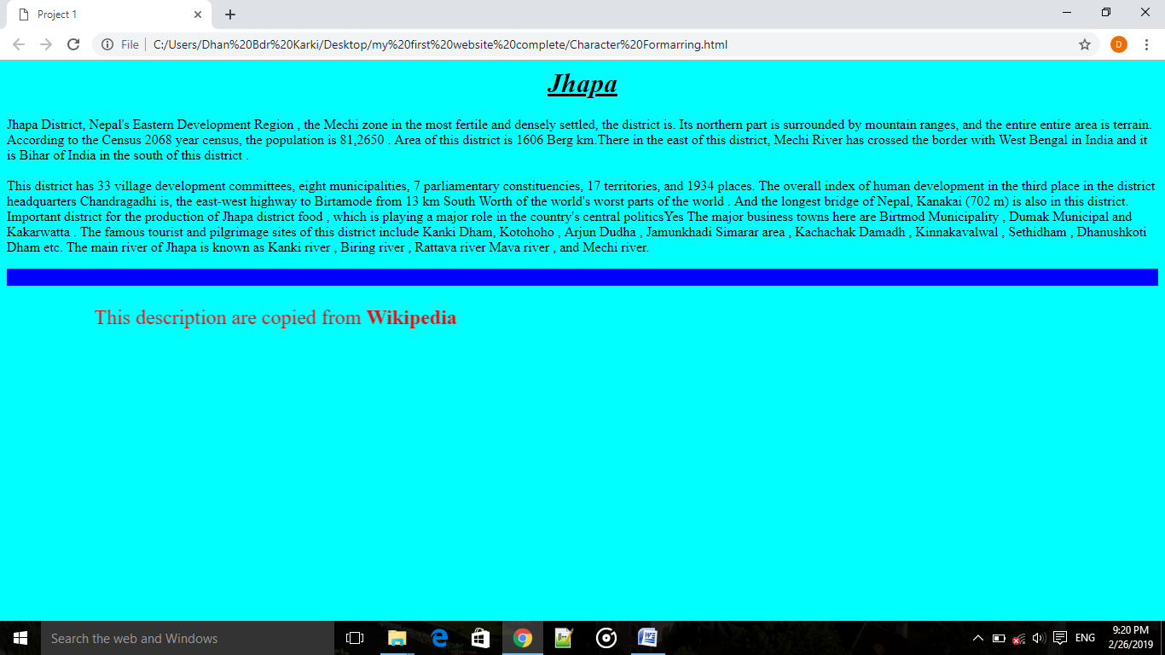

**Markup:**

<!DOCTYPE html>

<html>

<head>

<title>Project 2</title>

</head>

<body bgcolor="light blue">

<center><h1><font color=white face=Algerian><u>Gokyo Lake</font></u></h1>

<img src="D:/gokyolakes2.jpg" height=335 width=925 title=Gokyo Lakes></center>

<p>Gokyo Lakes are oligotrophic lakes in Nepal's Sagarmatha National Park, located at an altitude of 4,700–5,000 m (15,400–16,400 ft) above sea level. These lakes are the world's highest freshwater lake system comprising six main lakes, of which Thonak Lake is the largest. In September 2007, Gokyo and associated wetlands of 7,770 ha (30.0 sq mi) have been designated a Ramsar site.Gokyo lakes are located in Khumjung Village Development Committee of Solukhumbu District in Sagarmatha Zone in north-eastern Nepal. Gokyo Cho, also called Dudh Pokhari, is the main lake with an area of 42.9 ha (106 acres), and the village of Gokyo lies on its eastern shore. Thonak Cho is the largest lake with an area of 65.07 ha (160.8 acres). Gyazumpa Cho is 29 ha (72 acres) in size, followed by Tanjung Cho with an area of 16.95 ha (41.9 acres), and Ngojumba Cho with an area of 14.39 ha (35.6 acres). As sources of permanent fresh water they have high hydrological value. They feed on waters from various sources, such as seepage from the Ngozumpa glacier, a stream coming from the Renjo La pass from north-west and another stream originating from the Ngozumpa glacier in the east. These are glacier-fed freshwater wetlands and discharge water to the Dudh Kosi headway via the Taujon Lake and the Longabanga Lake. These lakes are deeper than previously assumed by the researchers. Fourth Lake (Thonak Cho) is the deepest lake (62.4m) followed by the Gokyo Lake which is 43 m.[4] A direct connection between the Gokyo Lake and the upper Thonak Cho and the Ngozumpa Cho has not been observed, but these lakes may be connected via underground seepage water. The Gokyo lake system is naturally vulnerable, as it is lying in an ecologically fragile and unstable zone. The outburst of Ngozumpa glacier is always a threat to the existence of the lakes.

The Gokyo lake system of 19 lakes is spread over an area of 196.2 ha (485 acres) lying between 4,600 and 5,100 m (15,100 and 16,700 ft). The wetland lies on the head of the Dudh Kosi, which descends from Cho Oyu.</P>

</body>

</html>

**Layout:**

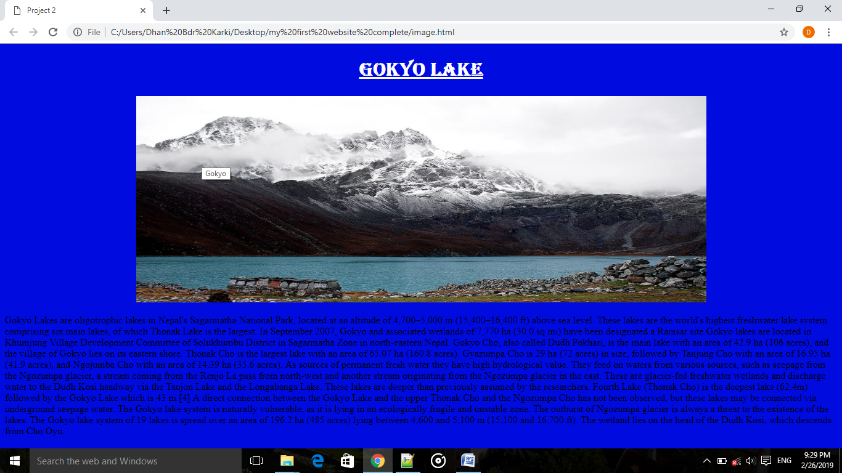

**Markup:**

**Markup:**

<!DOCTYPE html>

<html>

<head>

<title>Generation of computer in table</title>

</head>

<body bgcolor="red">

<center><h1><u width=100>Characteristics of Generation of computer in Table</u></h1></center>

<table border=2 width=1000 bgcolor="#FFFF00" align="center" height="500">

<tr>

<th colspan=6>Generation of Computer</th>

</tr>

<tr>

<th> </th>

<th> First Generation</th>

<th> Second Generation</th>

<th>Third Generation</th>

<th>Fourth Generation</th>

<th>Fifth Generation</th>

</tr>

<tr><td><b> Time period</b></td>

<td> 1940-1956</td>

<td>1956-1963</td>

<td> 1964-Early's 1970</td>

<td>Early's 1970-Till date</td>

<td>Present and beyond</td>

</tr>

<tr><td><b>Technology</b></td>

<td>Vacuum tubes</td>

<td>Transistor </td>

<td> Integrated Circuits</td>

<td>Microprocessor</td>

<td> Bio-chips</td>

</tr>

<tr><td><b> Processing Speed</b></td>

<td> Millisecond</td>

<td>Microsecond</td>

<td> Nanosecond</td>

<td> Picosecond</td>

<td> More Than Femtosecond</td>

</tr>

<tr><td><b>Memory</b></td>

<td>Vacuum Tubes</td>

<td>Magnetic Cores</td>

<td> Semiconductors</td>

<td>Semiconductors</td>

<td><Super-conductor/td>

</tr>

<tr><td><b>Storage</b></td>

<td>Magnetic tapes/drums</td>

<td>Magnetic tapes/disks</td>

<td> Magnetic Disks</td>

<td>Magnetic disks/ optical disks</td>

<td>Magnetic disks/ optical disks</td>

</tr>

<tr><td><b>I/O device</b></td>

<td>Punch Cards</td>

<td>Punch Cards</td>

<td> Keyboards/Monitor</td>

<td>Keyboards/Monitor/others</td>

<td>Advancement in I/O</td>

</tr>

<tr><td><b>size, cost, power consumption, heat generation</b></td>

<td>Very High</td>

<td>High</td>

<td>High </td>

<td>Very High</td>

<td>Very low</td>

</tr>

<tr><td><b>Reliability and Accuracy</b></td>

<td>Not Fully</td>

<td>More than 1G</td>

<td>Fully than previous </td>

<td>Fully than previous</td>

<td>-</td>

</tr>

<tr><td><b>Programming Languages</b></td>

<td>Machine</td>

<td>Assembly and High Level</td>

<td> High Level(Third Generation)</td>

<td>High Level(Fourth Generation) </td>

<td>Natural Language</td>

</tr>

<tr><td><b>Examples</b></td>

<td>IBM 700 Series, ENIAC, EDVAC etc</td>

<td>IBM 1620, IBM 7090, PDP1 etc</td>

<td>IBM 370 Series, CDC 7600, PDP 11,etc </td>

<td>IBM PC,Pentium PC, Apple etc</td>

<td></td>

</tr>

</body>

</html>

**Layout:**

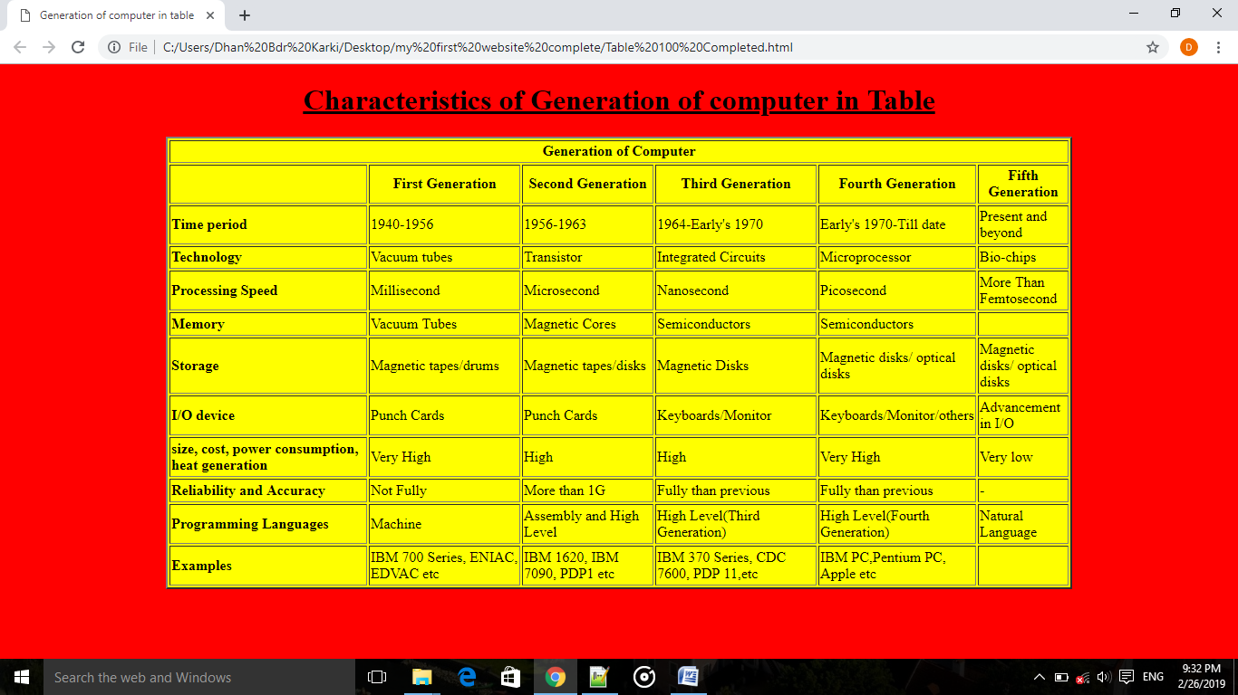

**Conclusion**

I was a wonderful and learning experience for me while working on this project. This project took me through the various phases of project development and gave me the real insight into the world of web page designing. The joy of working and the thrill involve while tackling the various problems and challenges gave me a feel of good web developers. I started the work the from the first day I got copy of my assignment and completed about 25% on the vary day. The research that I and my friend did encourage me to get more project and take a challenge of completing within allocated period of time. I got opportunity to revise the lessons that we have gone through. Teacher’s coordination and perfect touch with our group made me an opportunity to interact with teacher.I really enjoyed doing this project as a formal job.Now, I’m satisfied with my project work.

**Bibliography**

A. Computer Science, Grade XI

B. Wikipedia [en.wikipedia.org]

C. Google [www.google.com]